TASK 1

Select Your Operating System (OS): Choose an operating system that best suits your preferences and project requirements. Download and Install Windows 11.

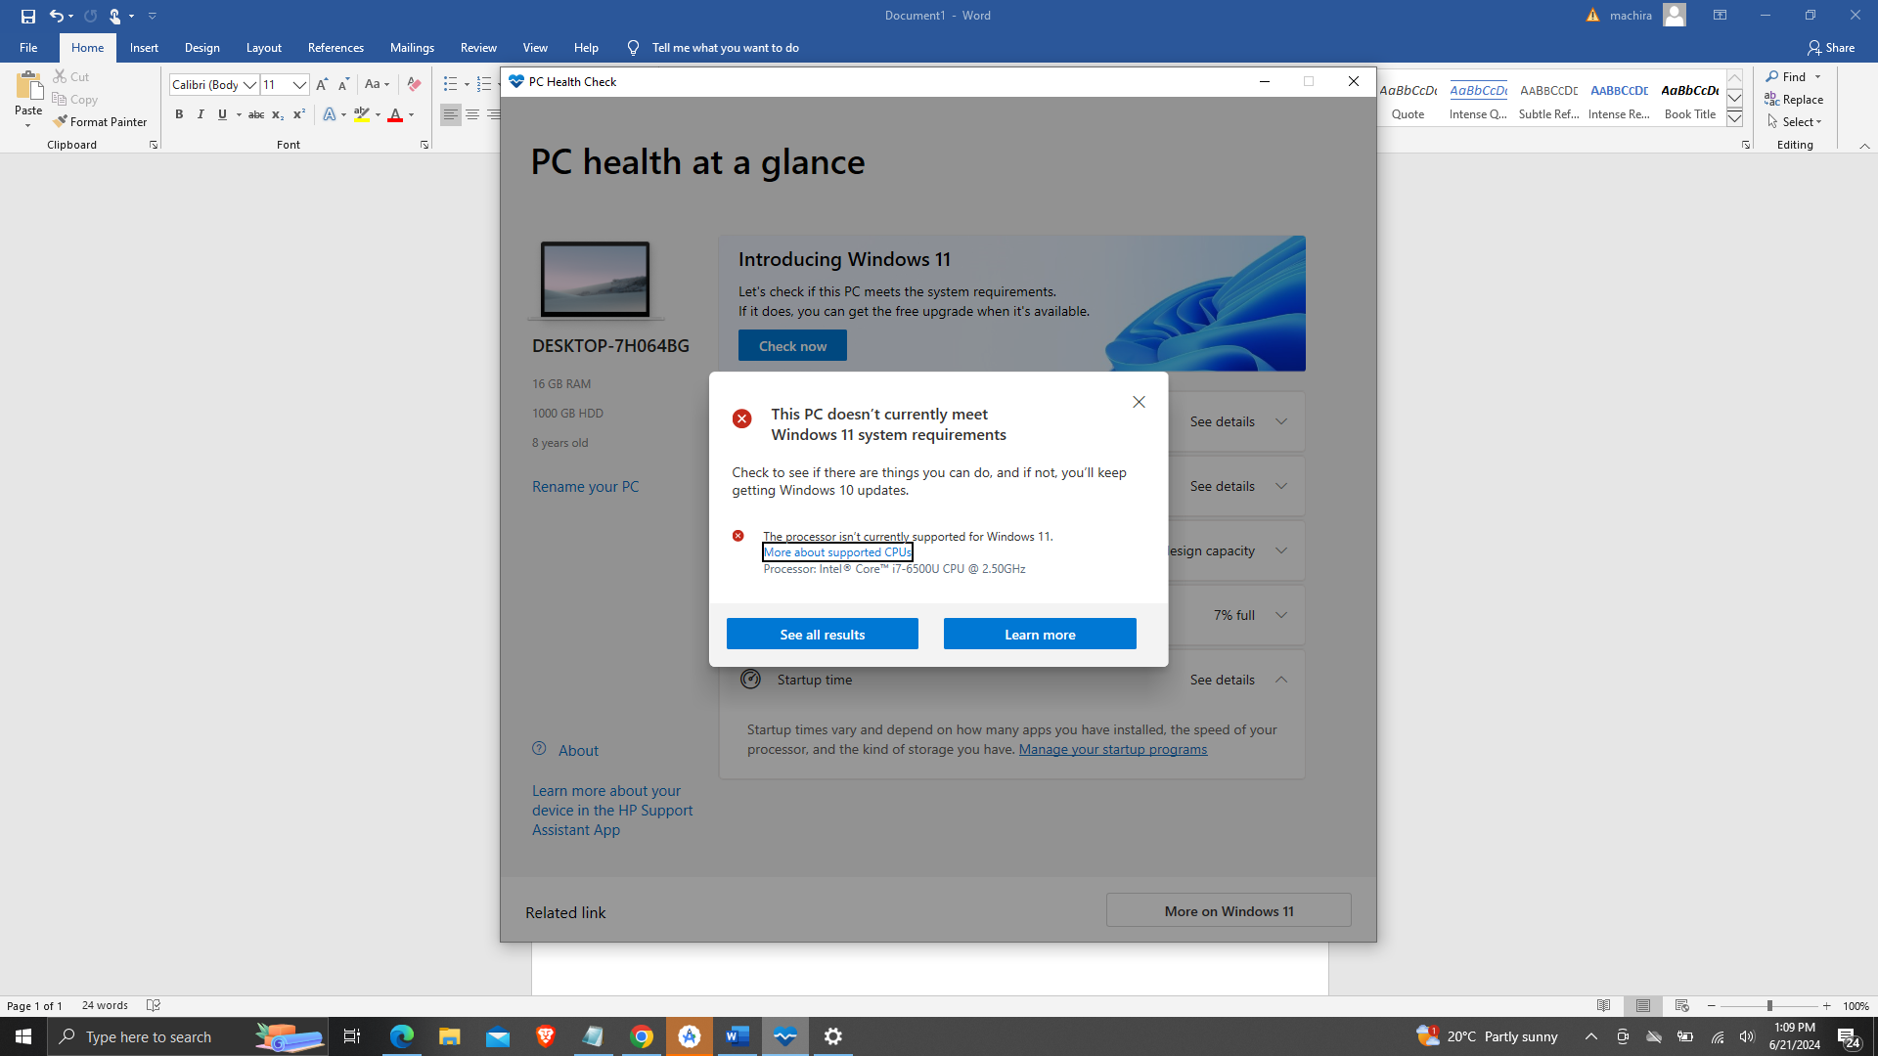

TASK 2

Install a Text Editor or Integrated Development Environment (IDE): Select and install a text editor or IDE suitable for your programming languages and workflow. Download and Install Visua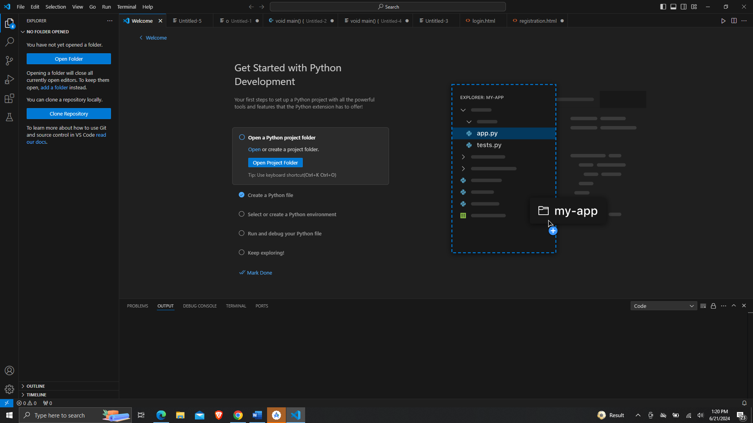

TASK 4

1. Install Necessary Programming Languages and Runtimes: Instal Python from [http://wwww.python.org](http://wwww.python.org/) programming language required for your project and install their respective compilers, interpreters, or runtimes. Ensure you have the necessary tools to build and execute your code.

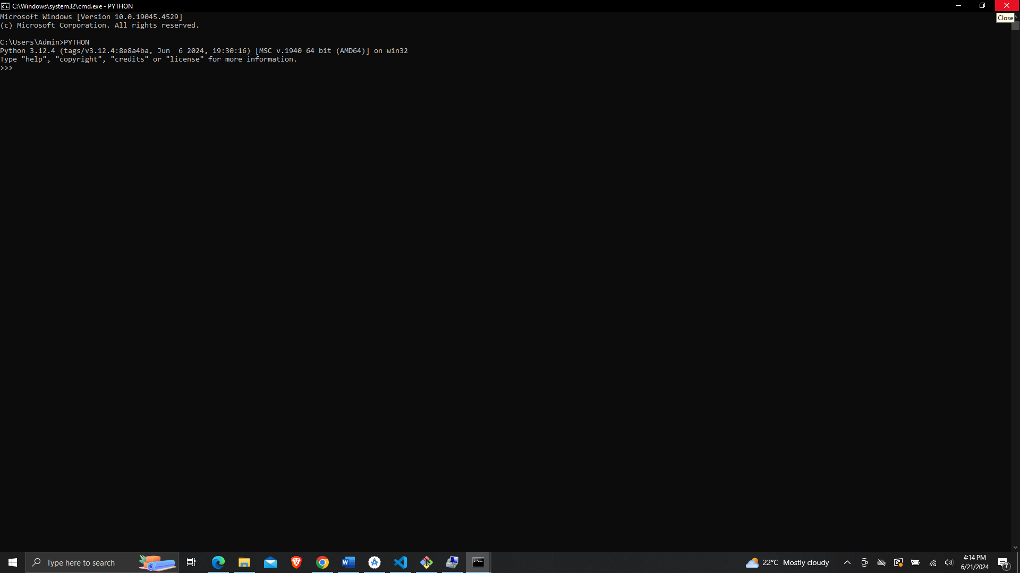

TASK 5

Install Package Managers: If applicable, install package managers like pip (Python).

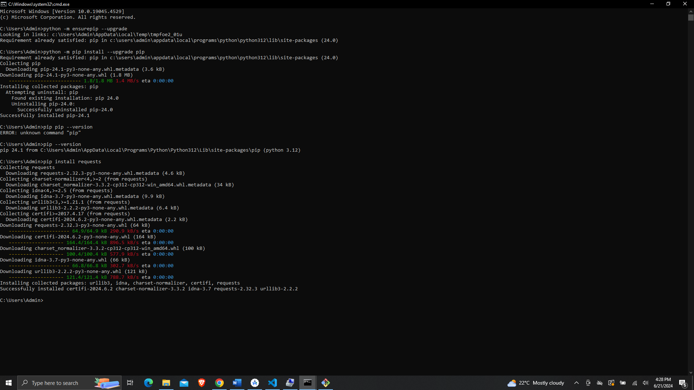

TASK 7

Configure a Database (MySQL): Download and install MySQL database.

